MYERSTOWN
SENIOR COMMUNITY CENTER
101 S. Railroad St, Suite 217
Myerstown, PA 17067
© 717-675-9546
Myerstown.SeniorCenter@lebanoncountypa.gov

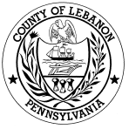


NEWSLETTER
DECEMBER 2025

Myerstown Senior Center is located at 101 S. Railroad St within the Myerstown Borough Hall on the 2nd floor and is open to all Lebanon County seniors 60 years of age and over.

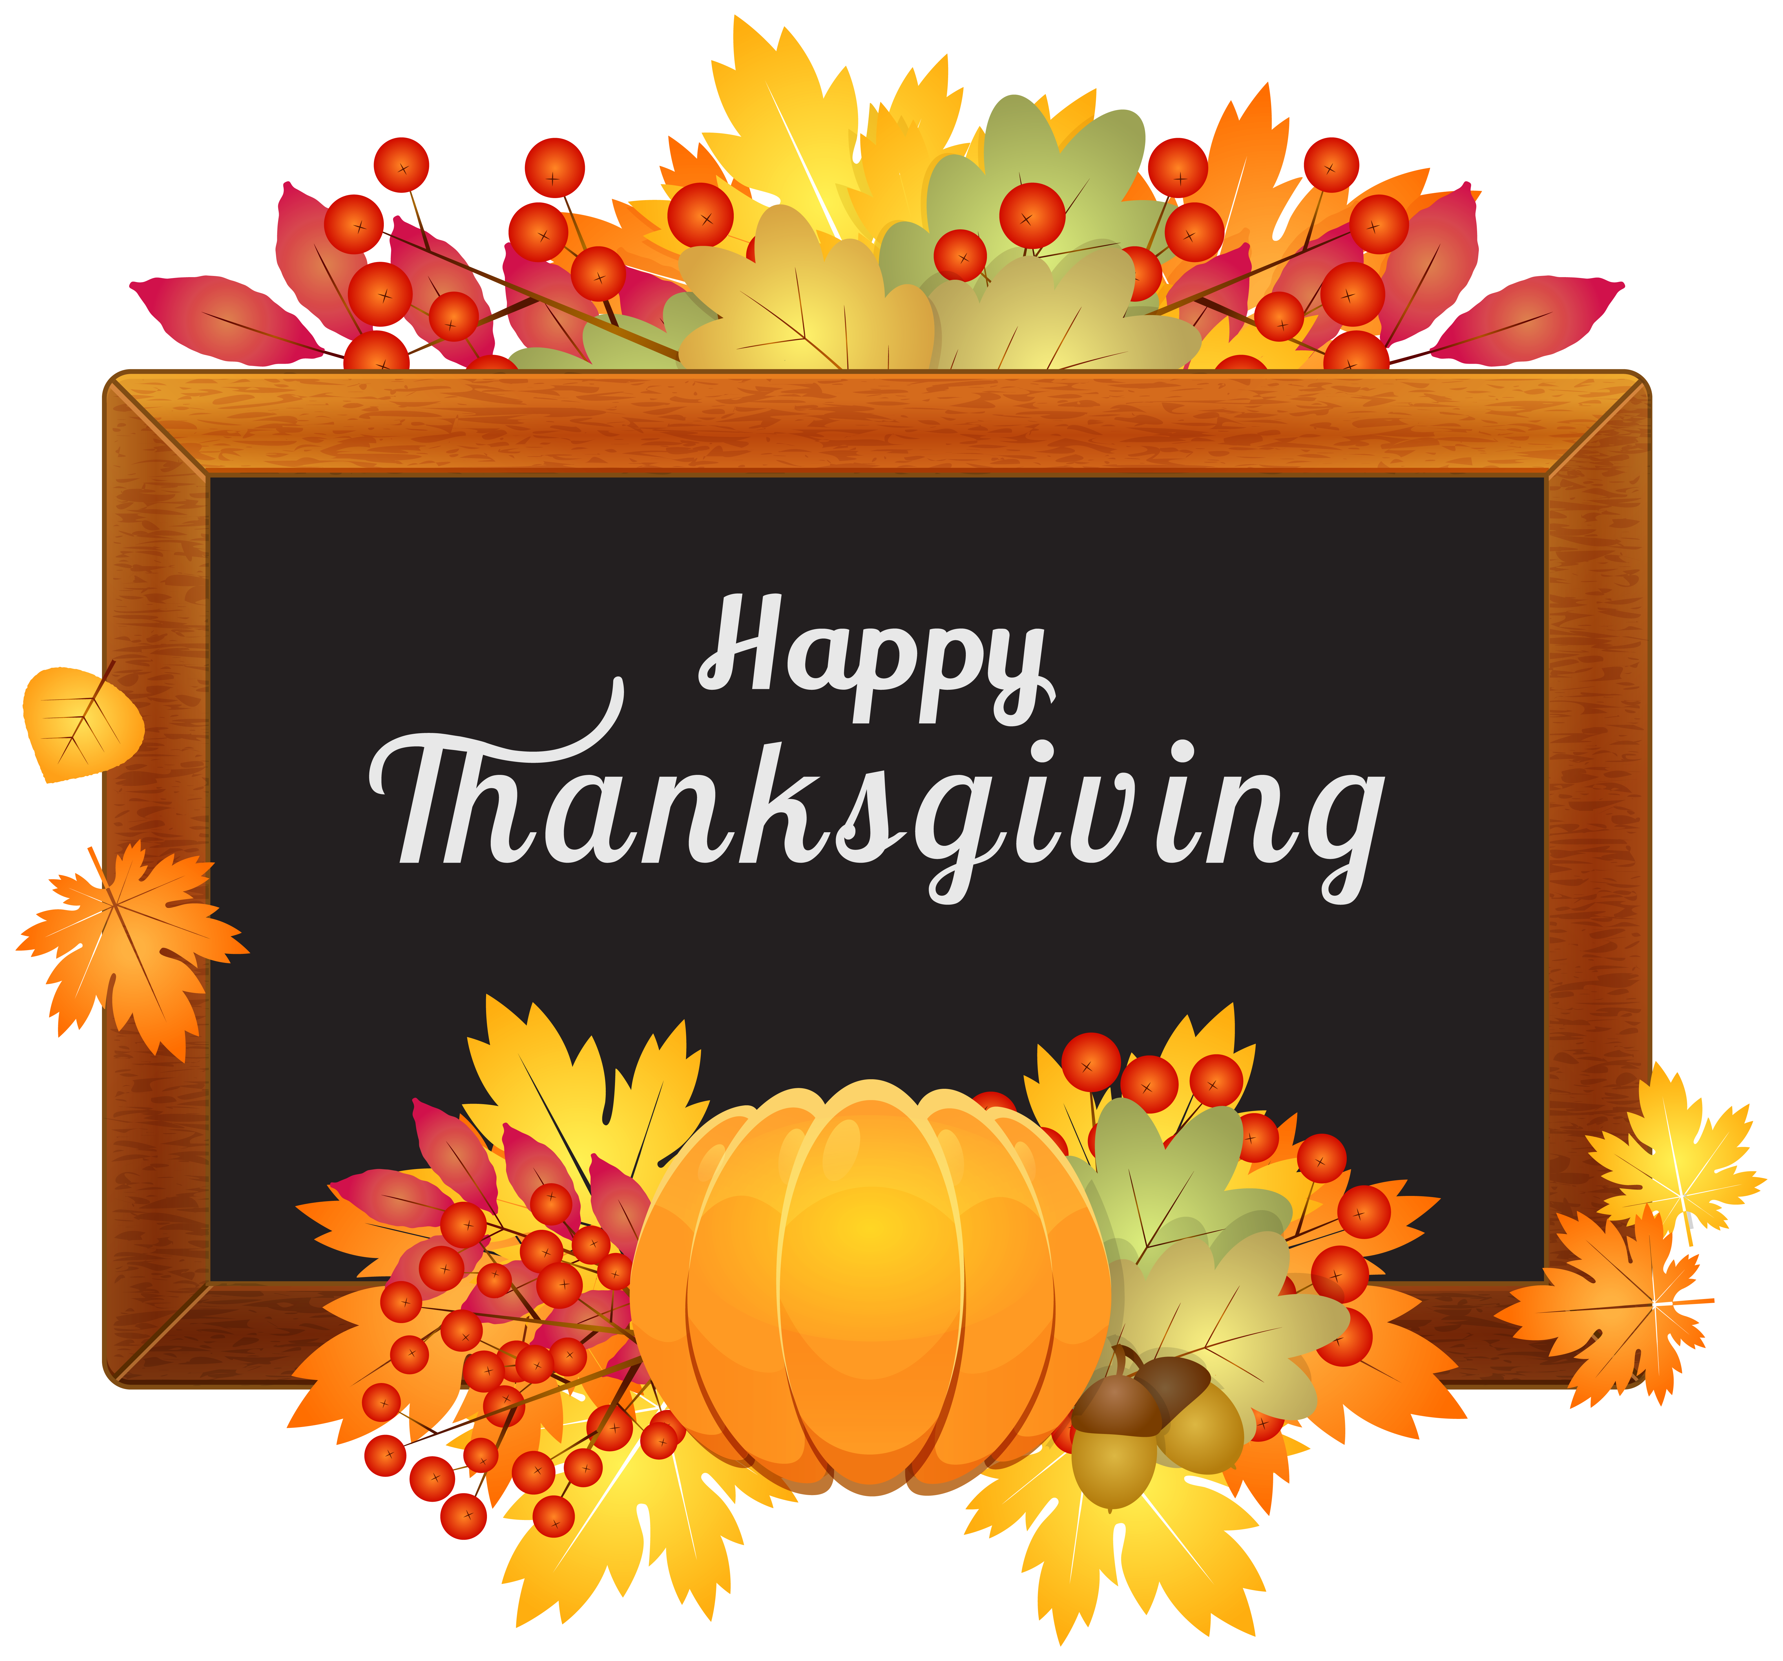

We offer both on and off-site activities such as day trips, social events, exercise programs, consumer education, bingo and daily meals offered 5 days a week. Meal reservations need to be made by 11:00 AM on the previous business day. Suggested donation for meals is $4.50. No membership fee to join us. We are open weekdays from 10:00 AM to 2:00 PM.
COMMUNITY PHONE NUMBERS
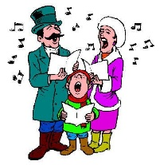
Lebanon County Area Agency on Aging:
717-273-9262
Social Security Office: 1-800-772-1213
PACE-PACENET: 1-800-225-7223
Rent Rebate Office: 1-888-728-2937
Medicare: 1-800-633-4227
Anti-Fraud Hotline: 1-855-303-9470

ANNOUNCEMENT
- As of September 1st, meal donations will no longer be collected at Senior Centers. A donation statement will be sent out to meal consumers at the end of the month.
- Food Drive for Myerstown Food Bank -
Accepting non-perishable food items by Tuesday, 12/9

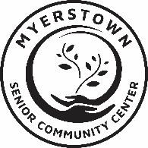

SPECIAL PROGRAM INFORMATION
- Christmas Luncheon & Entertainment at Country Fare
Wednesday, 12/3 - 11:30 AM (Sign up by 11/26)
- Bus Tript o American Music Theatre & Lunch - King’s Farmhouse
Thursday, 12/4. Depart: 8:30 AM (Senior Center parking lot), Return: 4:30 PM
- Chair Yoga for Seniors (DVD)
Mondays 1:00 – 1:30 PM
- Chair Tai-Chi Fit for Seniors (DVD)
Wednesday 1:00 – 1:30 PM
- Christmas Special Lunch (catered by Heisey’s) & Christmas Carol Sing-Along
Tuesday, 12/16. 12:00-2:00 PM. $15 by 12/9
- Soup & Sandwich Special Meal*
Thursday, 12/18 - 12:00 PM
Menu: Beef Vegetable Soup, Cheesy Cauliflower Soup, Turkey Sandwich, Coleslaw, Coconut Cream Cake, Milk (order by 12/11)
- “Scams for Senior Citizens” by the State Police
Tuesday, 12/30 -11:00 AM

UPCOMING EVENTS
- 1/7 – Happy New Year Luncheon - Mick’s
- 1/22 – Snowman Luncheon - Cedar Grill
- 1/27 – “Myerstown Library Services” Presentation by Sarah Bair

*Program w/cost & reservation required
**All information subject to change

