

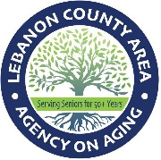
MYERSTOWN SENIOR COMMUNITY CENTER
INFORMATIONAL PRESENTATIONS
*All presentations start at 10:30 AM

- Tuesday, January 27th
“Myerstown Library Services” by Sarah Bair
- Tuesday, February 24th
“Romance Scam” by Kate Kleinert
- Tuesday, March 31st
“Scams Prevention & Financial Literacy” by Emma Bomberger from the Department of Banking & Securities
- Tuesday, April 28th
“Dementia” Nutrition Education by Barbara Goll
- Tuesday, May 26th
“Paint & Sip” Program with light refreshment by Alpine Valley Rehab
- Tuesday, June 30th
“Albright Life Center Services” by Mileny Ayestas

*lunch can be ordered for 12 PM
with suggested donation $4.50
**All schedule subject to change

Myerstown Senior Community Center
101 S. Railroad St. Suite 217
Myerstown, PA 17067
717-675-9546

