MYERSTOWN
SENIOR COMMUNITY CENTER
101 S. Railroad St, Suite 217
Myerstown, PA 17067
© 717-675-9546
Myerstown.SeniorCenter@lebanoncountypa.gov

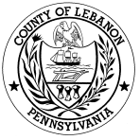

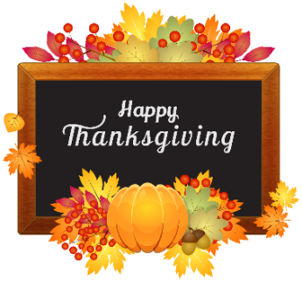
NEWSLETTER
NOVEMBER 2025

Myerstown Senior Center is located at 101 S. Railroad St within the Myerstown Borough Hall on the 2nd floor and is open to all Lebanon County seniors 60 years of age and over.

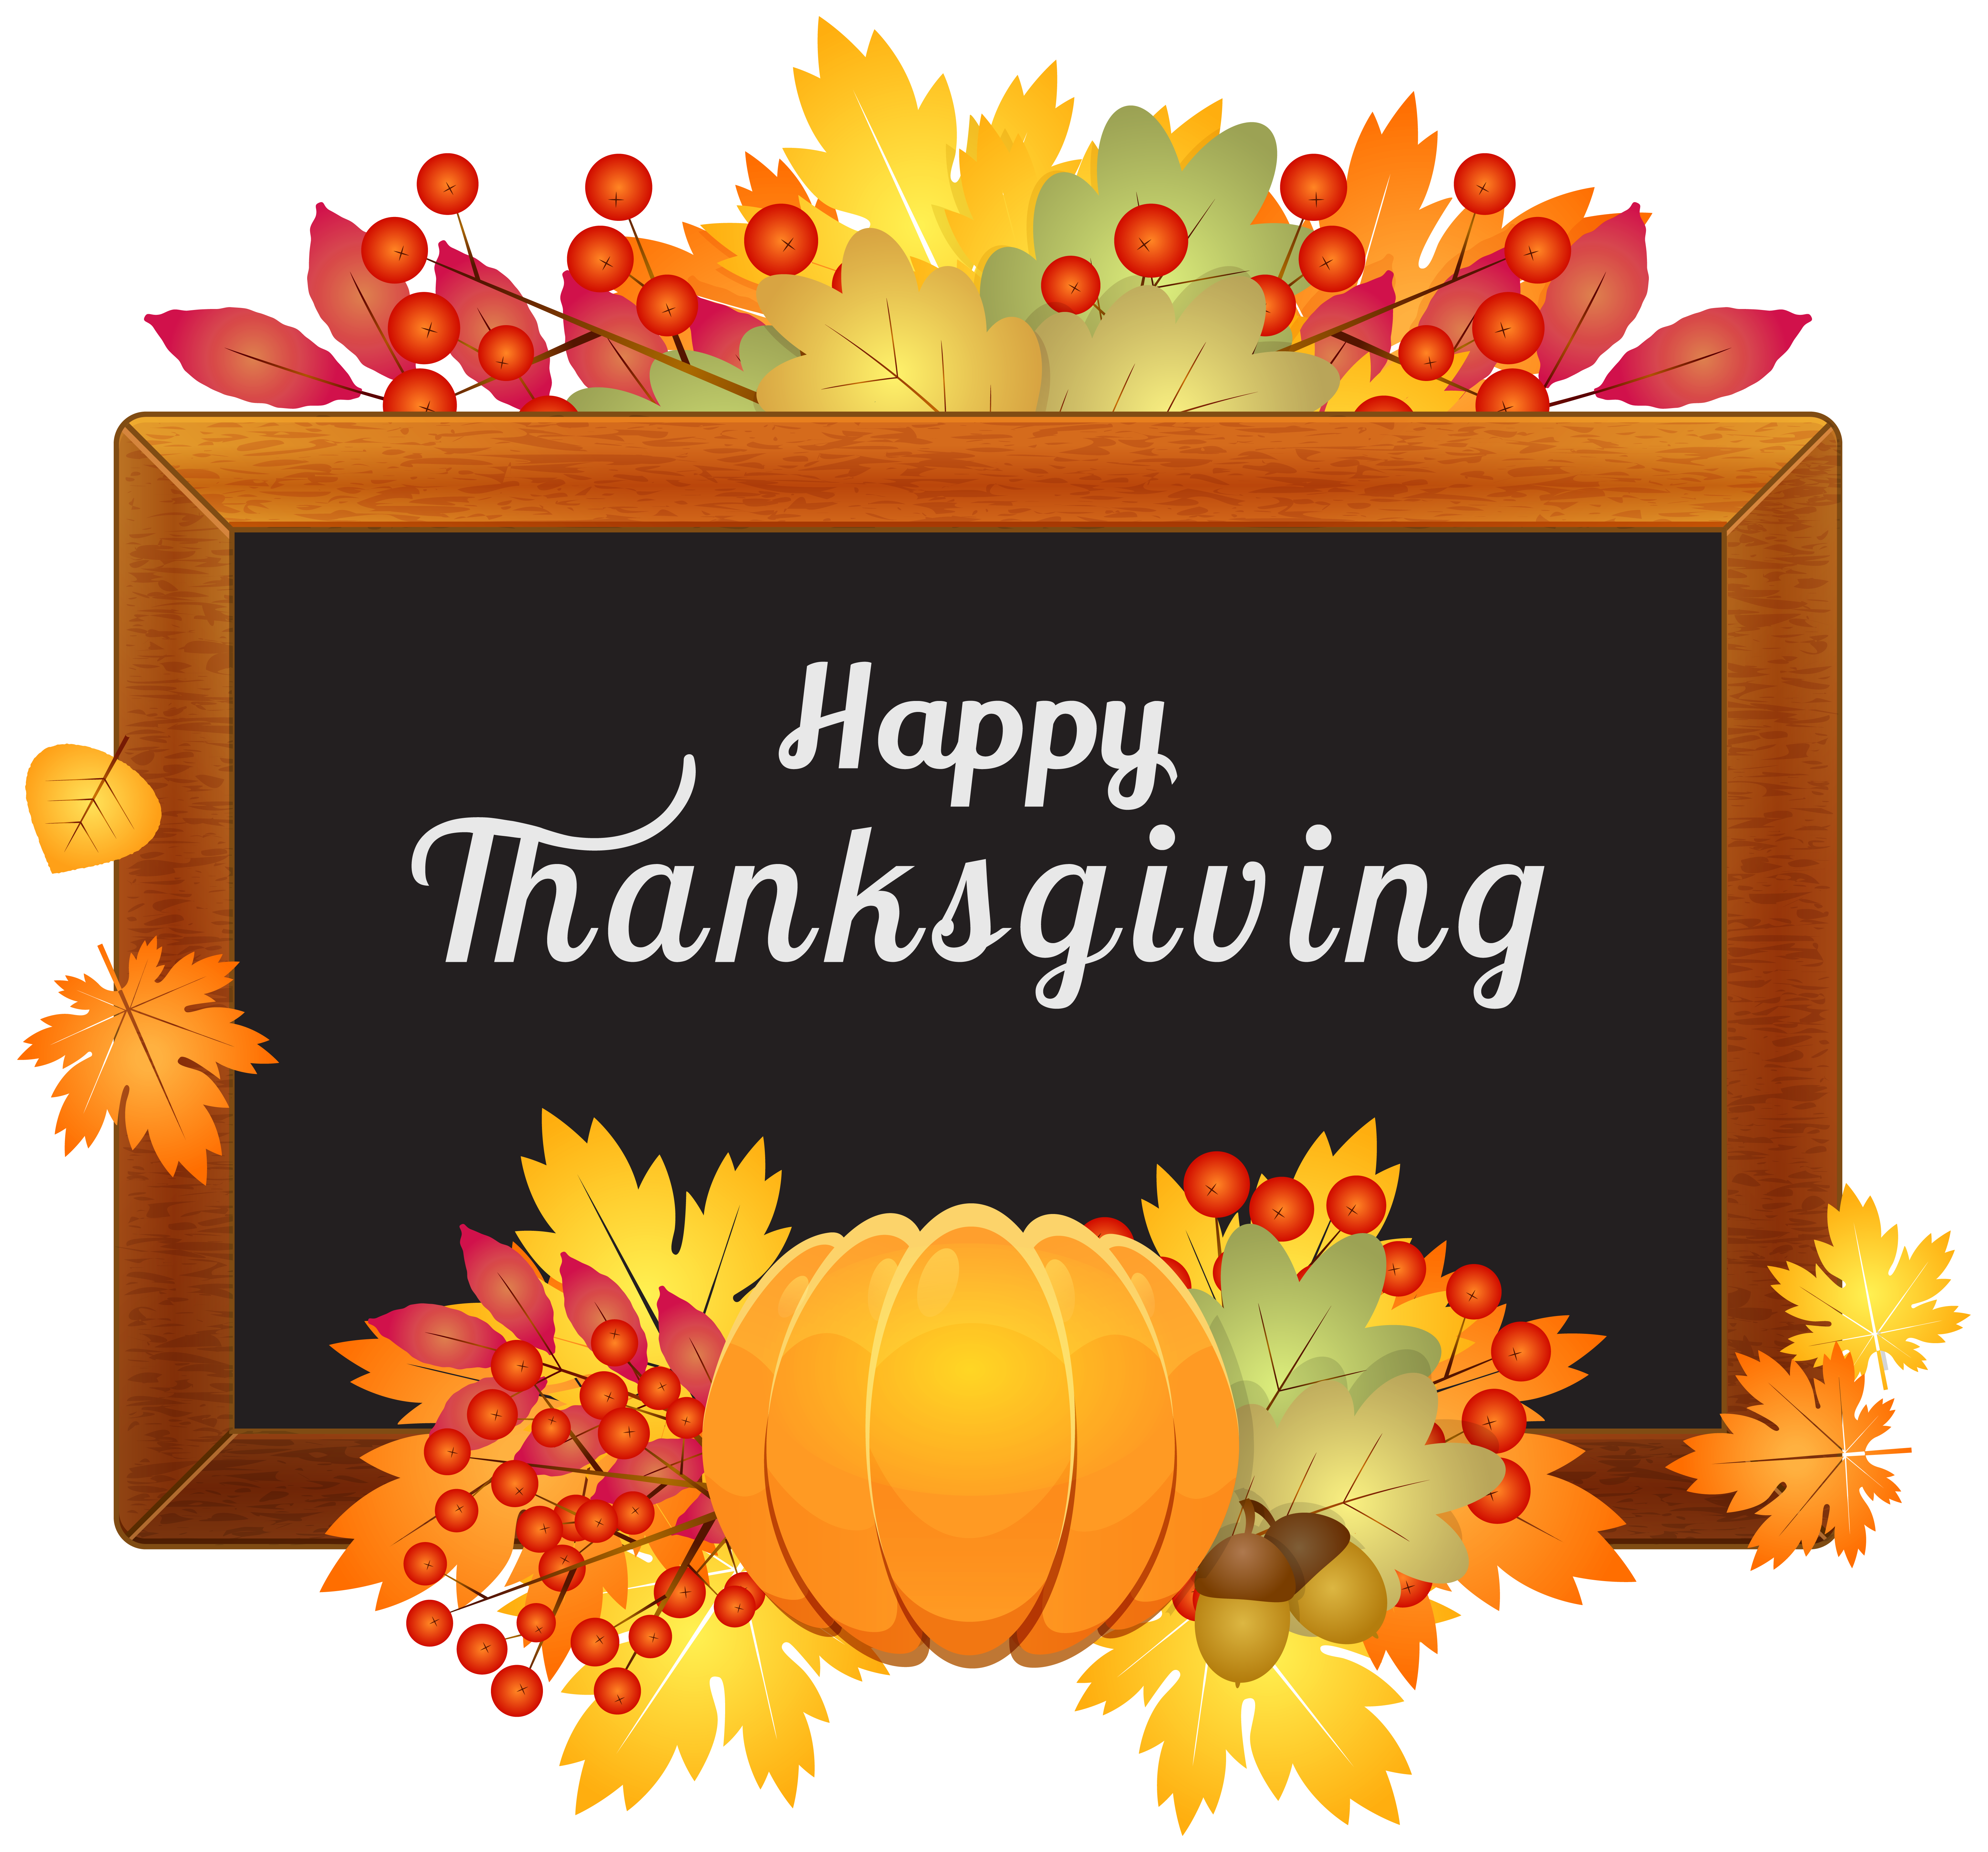

We offer both on and off-site activities such as day trips, social events, exercise programs, consumer education, bingo and daily meals offered 5 days a week. Meal reservations need to be made by 11:00 AM on the previous business day. Suggested donation for meals is $4.50. No membership fee to join us. We are open weekdays from 10:00 AM to 2:00 PM.
COMMUNITY PHONE NUMBERS
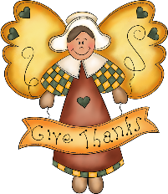
Lebanon County Area Agency on Aging:
717-273-9262
Social Security Office: 1-800-772-1213
PACE-PACENET: 1-800-225-7223
Rent Rebate Office: 1-888-728-2937
Medicare: 1-800-633-4227
Anti-Fraud Hotline: 1-855-303-9470

NEW PROGRAM INFORMATION

- Chair Yoga for Seniors/Beginners DVD: Monday, 1:00-1:30 PM
- Chair Tai-Chi Fit for Seniors DVD: Wednesday, 1:00-1:30 PM
- Quarter Bingo: last Friday of the month, 10:30-11:45 AM

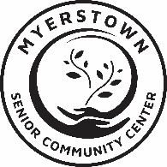

ANNOUNCEMENT
As of September 1st, meal donations will no longer be collected at Senior Centers. A donation statement will be sent out to meal consumers at the end of the month.

SPECIAL PROGRAM INFORMATION
- Happy November Luncheon at DoGood’s*
Wednesday, 11/5 – 12:00 PM Sign-up by 10/29
- Chair Yoga for Seniors (DVD)
Mondays 1:00 – 1:30 PM
- Chair Tai-Chi Fit for Seniors (DVD)
Wednesday 1:00 – 1:30 PM
- Soup & Sandwich Special Meal*
Thursday, 11/20 – 12:00 PM
Menu: NE Clam Chowder, Turkey Noodle Soup, Ham Sandwich, Coleslaw, Pecan Pie, Milk
Order by 11/13
- Thanksgiving Banquet & Entertainment at Neptune Banquet Hall
Thursday, 11/13 – 12:00 PM
Sign-up & $15 by 11/16
- “Diabetes” Nutrition Education by Barbara Goll
Tuesday, 11/25 – 11:00 AM
- Picnic Bag Lunch*
Tuesday, 11/25 – 12:00 PM
Menu: Turkey Sandwich, Potato Salad,
3-beans Salad, Chips, Cookie, Milk.
Order by 11/18
UPCOMING EVENTS
- 12/3 – Christmas Lunch at Country Fare
- 12/4 – Bus Trip to AMT & King’s Farmhouse
- 12/16 – Christmas Carol Sing-Along & Catered Lunch by Heisey’s
*Program w/cost & reservation required
**All information subject to change

