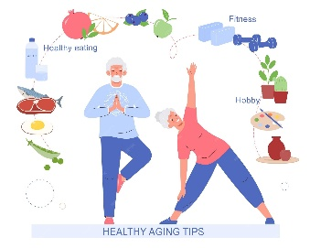
Nutrients and Your Needs for Older Adults

Nutrients are substances in your food that keep your body working well. Eating too much or too little of some nutrients may increase your risk of certain chronic diseases, such as heart disease and high blood pressure.
Older adults have different nutritional needs than other age groups. The Nutrition Facts label can help you monitor some of the nutrients in your diet.
This booklet gives some basic facts about the nutrients commonly seen on the Nutrition Facts label. Use this page to help you talk to your healthcare provider about which nutrients you should track closely for your overall health. Visit www.myplate.gov/ for more information on making healthy food choices.

Get More of These Nutrients: Dietary Fiber, Vitamin D, Calcium, and Potassium
Many older adults do not get the recommended amount of these nutrients. More often, compare and choose foods to get more of these nutrients on most days.
Dietary fiber is a type of carbohydrate that cannot be easily digested. It can speed up the movement of food and waste through the body increasing the frequency of bowel movements. Diets higher in dietary fiber may reduce the risk of developing cardiovascular disease. The Daily Value for dietary fiber is 28 grams (g) per day.*
Calcium is a mineral that is important for bone health. It also helps with muscle and nerve function, blood clotting, and hormone secretion. Diets higher in calcium can reduce the risk of developing osteoporosis (weak and brittle bones). The Daily Value for calcium is 1,300 milligrams (mg) per day.*
Vitamin D helps your body absorb calcium and is important for bone health. It also plays a role in blood pressure management, hormone production, and immune and nervous system function. Diets higher in vitamin D can reduce the risk of developing osteoporosis (weak and brittle bones). The Daily Value for vitamin D is 20 micrograms (mcg) per day.*
Potassium is a mineral that helps with fluid balance and heart, muscle, and nervous system function. The Daily Value for potassium is 4,700 mg per day.*
Get Less of These Nutrients: Saturated Fat, Sodium, and Added Sugars
Most older adults get too much of these nutrients. More often, compare and choose foods to get less of these nutrients each day.

