Monday | Tuesday | Wednesday | Thursday | Friday
9am – 3pm  open gym for walking  except when classes are in session | Fees and Donations:  - Toning $5  - Line Dancing $3  - It’s a Ball $5  - BEATS Cardio $5  - Qigong $5  FIRST CLASS FREE |  | 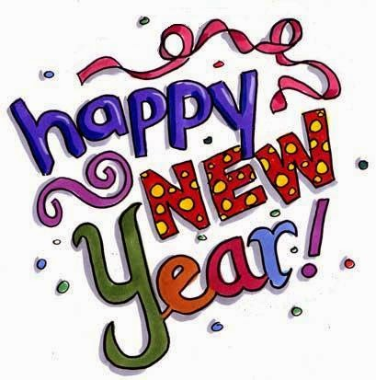  1 CLOSED | 2  9am—3pm Billiards & Library  8am Pickleball  10:30am Penny Bingo LIB*  1pm Ping Pong  1pm Shuffleboard/Cornhole
5 9am—3pm Billiards & Library  9:30 am Tai Chi for Arthritis  10:30am Needle Arts  1030am Pickleball  1p Ping Pong  1pm Shuffleboard/Cornhole  1:15pm Toning w/ Weights* | 6 9am—3pm Billiards & Library 9am Band Together  10am Line Dancing  11:15am It’s A Ball Exercise*  12:30pm Pickleball  12:30 Pinochle (craft room)  1pm Ping Pong  1pm Shuffleboard/Cornhole | 7 9am—3pm Billiards & Library 8:30am Pickleball  10:30am Bunco or Cards  10:45am BEATS: Drumming  1pm Ping Pong  1pm Shuffleboard/Cornhole | 8 9am—3pm Billiards & Library  9am Band Together  10am Qigong*  11:15 Toning w/Weights*  12pm- Soup & Salad $4.50  1pm Ping Pong  1pm Tai Chi for Arthritis | 9 9am—3pm Billiards & Library  915-1015 Java Journey Timber Creek 494 W. Lincoln Ave, Myerstown  8am Pickleball  10:30am Penny Bingo LIB*  1pm Ping Pong  1pm Shuffleboard/Cornhole
12 9am—3pm Billiards & Library  9:30 am Tai Chi for Arthritis  10:30am Needle Arts  1030am Pickleball  1230 Craft Day  1pm Ping Pong  1pm Shuffleboard/Cornhole  1:15pm Toning w/ Weights* | 13  9am—3pm Billiards & Library  9am Band Together  10am Line Dancing  11:15am It’s A Ball Exercise*  12:30 Pickleball  1pm Ping Pong | 14 9am—3pm Billiards & Library  8:30am Pickleball  10:30am Bunco or Cards  10:45am BEATS: Drumming  1230-130 Planning Mtg- Library  1pm Ping Pong  1pm Shuffleboard/Cornhole  2p Missing Apron- Ruby Tuesday’s  1351 Quentin Rd | 15 9am—3pm Billiards & Library  9am Band Together  10am Qigong*  1030- 1130 Shared Ride program Signups-LIBRARY  11:15 Toning w/Weights*  1pm Ping Pong  1pm Tai Chi for Arthritis | 16  9am—3pm Billiards & Library 8am Pickleball  10:30am Penny Bingo LIB*  12pm Ping Pong  1pm Shuffleboard/Cornhole
19  CLOSED MLK DAY   | 20 9am-3pm Billiards & Library  9am Band Together  10am Line Dancing  11:15am It’s A Ball Exercise*  12:30 Pickleball  12:30 Pinochle (craft room)  1pm Ping pong  1pm Shuffleboard/Cornhole | 21 9am-3pm Billiards & Library 8:30am Pickleball  10:30am Bunco or Cards  10:45am BEATS: Drumming  1pm Quarter Bingo  1pm Ping Pong  1pm Shuffleboard/Cornhole | 22 9am—3pm Billiards & Library  9am Band Together  10am Qigong*  11:15 Toning w/Weights*  12pm- Soup & Salad $4.50  1pm Ping Pong  1pm Tai Chi for Arthritis | 23  9am—3pm Billiards & Library 8am Pickleball  10:30am Penny Bingo LIB*  1pm Ping Pong  1pm Shuffleboard/Cornhole
26 9am—3pm Billiards & Library  9:30 am NO Tai Chi for Arthritis  10:30am Needle Arts  1030am Pickleball  1pm Ping Pong  1pm Shuffleboard/Cornhole  1:15pm Toning w/ Weights* | 27  9am-3pm Billiards & Library  9am Band Together  10am Line Dancing  11:15am It’s A Ball Exercise*  12:30 Pickleball  1pm Ping Pong  1pm Shuffleboard/Cornhole | 28  9am-3pm Billiards & Library 8:30am Pickleball  10:30am Bunco or Cards  10:45am BEATS: Drumming  1230- Birthday Social -al shade  1pm Ping Pong  1pm Shuffleboard/Cornhole | 29  9am—3pm Billiards & Library  9am Band Together  10am Qigong*  11:15 Toning w/Weights*  1pm Ping Pong  1pm NO Tai Chi for Arthritis | 30  9am—3pm Billiards & Library 8am Pickleball  10:30am Penny Bingo LIB*  1pm Ping Pong  1pm Shuffleboard/Cornhole

